|  |  |
| --- | --- |
| NAMES: | STUDENT IDS: |
| Zheng Hao | A0197899R |
| Wang Siling | A0197996W |
| Ye Donglai | A0197890J |
| Huang Yichen | A0175172E |
| Shan Changhan | A0197908J |

**Question 1**

1. Calibrate the three GARCH(1,1) parameters using the Maximum Likelihood Method.
   1. Start with trial value of $α,β,ω$
   2. Calculate Likelihood = $\sum_{i=1}^{m}{-\ln{(v_{i})}}- \frac{{u_{i}}^{2}}{v_{i}}$
      1. $m$ is the number of return data points, $m = 522$
      2. $u_{i}$ is return, $u_{i}= \ln{(\frac{S_{i}}{S_{i-1}}})$
      3. $v_{i}$ is daily variance estimated by GARCH, $v_{I}= ω+ αu_{i-1}^{2}+ βv_{i-1}$
   3. Use Excel Solver to search for $α,β,ω$ that maximize Likelihood
   4. 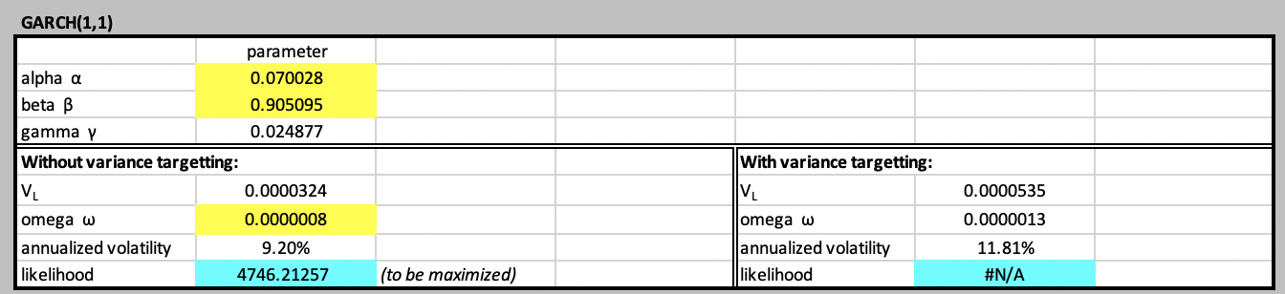The Parameters are $α= 0.070028,β=0.905095,ω=0.0000008$
2. Calibrate the GARCH(1,1) parameters using the Maximum Likelihood Method and Variance Targeting.
   1. Using the same method to calculate Likelihood
   2. Fix $V_{L}$, long run average variance to unweighted average daily variance
   3. Use Excel Solver to search for $α,β$ that maximize Likelihood. In this case $ω$ is fixed, $ω= V_{L}*(1-α-β)$
   4. 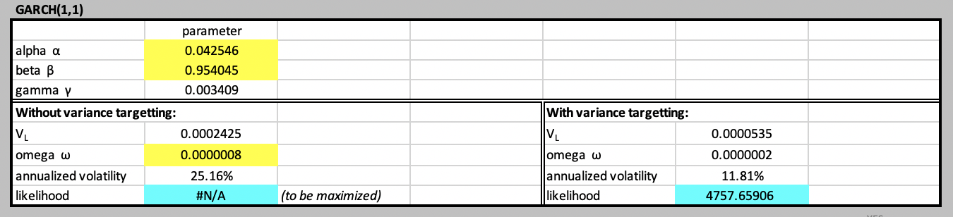The Parameters are $α= 0.042546,β=0.954045,ω=0.0000002$
3. Calculate the Ljung-Box statistics for each. Comment on these results and what it means that the calibrated GARCH(1,1) model has achieved.
   1. The autocorrelation for daily returns seems not significant since Ljung-Box statistics is 47.953, relatively small.
   2. The autocorrelation for daily variance(squared returns) seems significant since Ljung-box test statistics is 360.851, relatively large. Lag 1, 17, 35 are at peak compared to other lags.
   3. The autocorrelation for standardized variance seems not significant since Ljung-box test statistics is 87.170, relatively unremarkable. However, several lags have larger autocorrelation compared to others.

In conclusion, there is heteroskedasticity in return series and applying GARCH method is reasonable. GARCH(1,1) achieves acceptable results as the standardized squared returns generally are not autocorrelated.

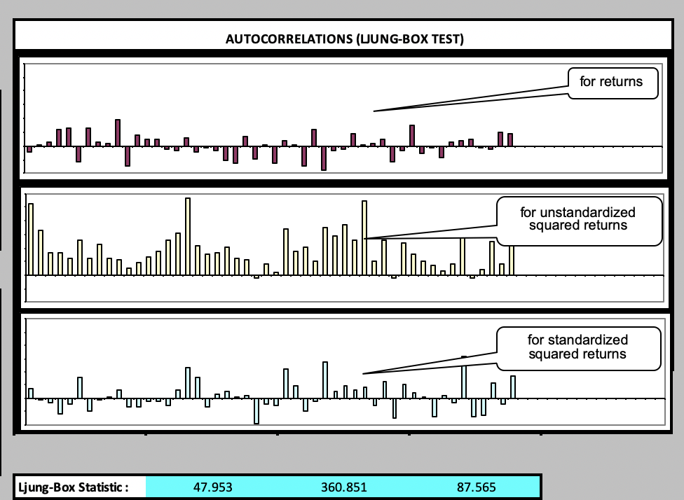

**Question 2**

**Given the ATM Implied Volatilities:**

|  |  |
| --- | --- |
| Tenor (years) | Implied Volatility |
| T0 = 0.00 |  |
| T1 = 0.25 | 30.00% |
| T2 = 0.50 |  |
| T3 = 1.00 | 28.00% |
| T4 = 2.00 |  |

1. Complete the following table of variances and volatility, in your answer sheet.

|  |  |  |  |
| --- | --- | --- | --- |
| Period | Implied  Volatility | Total Variance | Comment on how we calculate total variance |
| T0→T1 | 30.00% | 0.0225 | 0.3*0.3*0.25 |
| T0→T2 | 0.2867 | 0.0411 | 0.0225+0.0186 |
| T1→T2 | 0.2728 | 0.0186 | 0.0559/3 |
| T2→T3 | 0.2728 | 0.0372 | 0.0559/3*2 |
| T1→T3 | 0.2728 | 0.0559 | 0.28*0.28-0.0225 |
| T0→T3 | 28.00% | 0.0784 | 0.28*0.28 |

1. Given the volatilities provided at the start of the question (assume these are FIXED), if there were a series of major policy and political events in the period T1→T2, what would be the effect on the variances in (b) and why? Do not complete the table in the exam question sheet, make a copy on your answer sheet.

|  |  |
| --- | --- |
| Period | Impact on expected total variance |
| T0→T1 | Expected total variance won’t change since the major events happened after T1. |
| T0→T2 | Expected total variance increase. |
| T1→T2 | Expected total variance increase, and the increased amount equals that of T0-T2. |
| T2→T3 | Expected total variance decrease, and the decreased amount equals the increased amount of T1-T2, since the total variance from T1-T3 is fixed. |
| T1→T3 | Won’t change |
| T0→T3 | Won’t change |

1. what is the arbitrage constraint on the volatility for the period T0→T4 ?

$${σ_{T0-T4}}^{2}*\left(T_{4}-T_{0}\right)≥ {σ_{T0-T3}}^{2}*\left(T_{3}-T_{0}\right)={0.28}^{2}*1$$

$$σ_{T0-T4}≥0.1979$$

**Given the following option prices:**

|  |  |  |  |
| --- | --- | --- | --- |
| Strike | $ 1.3500 | $ 1.4000 | $ 1.5000 |
| Call Premium |  | $ 0.1800 | $ 0.1400 |
| Put Premium |  | $ 0.1550 | $ 0.2150 |

1. what is the prevailing outright forward price?

According to call-put parity, we have

$$c(0)-p(0) = s(0) - K*D(T)$$

and we have condition1: c(0)=0.18,p(0)=0.155,K=1.4 and

condition 2: c(0)=0.14,p(0)=0.215,K=1.5

Hence we get **S(0) = 1.425 , D(T)=1**

1. what are the maximum and minimum arbitrage-free prices for the Call and Put Options strike $1.3500?

To be arbitrage-free, the prices of options need to meet following conditions:

* 1. C(1.35)-P(1.35)+1.35 = 1.4250
  2. 0 $≤$ (C(1.35)-C(1.4))/(1.4-1.35) $≤$ 1
  3. 0 $≤$ (C(1.35)-C(1.4))/(1.4-1.35)- (C(1.4)-C(1.5))/(1.5-1.4) $≤$ 1
  4. 0 $≤$ (P(1.4)-P(1.35))/(1.4-1.35) $≤$ 1
  5. 0 $≤$ (P(1.5)-P(1.4))/(1.5-1.4)- (P(1.4)-P(1.35))/(1.4-1.35) $≤$ 1

Hence we have $$0.2≤C(1.35)≤0.23$$

$$0.125≤P(1.35)≤0.155$$

1. if the price of the Put strike $1.3500 is $0.1300, what is the arbitrage-free price of the Call strike $1.3500?
$$c=p+s\left(0\right)-K*D\left(T\right)=0.205$$

2. assume the prices for the Call and Put Options strike $1.3500 are $0.2350 and $0.1200 respectively. Identify the three possible arbitrages, explaining in each case:
   1. call-out parity (K=1.35)

c – p =0.115 > s(0) – K * D(T) = 0.075

The price of the call option is too high in respect of the put option. Consider portfolio V = P(1.35) – C(1.35) + S

V(0) = P(t0) - C(t0) + S(t0) =0.12 – 0.2350 + 1.425 = 1.31

V(T) = ${(K – S(T) )}^{+}-{\left(S\left(T\right)-K \right)}^{+}-1.31+S(T)$ = K – 1.31 =0.04

Hence the **notional amount is 1.31 and P&L is +0.04.** There is no risk in the arbitrage strategy, no matter what S(T) is, we can lock in the P&L +0.04.

* 1. call spread

consider portfolio V= - C(1.35) + C(1.4)

V(t0) = -0.235 + 0.18 = -0.055 **notional amount = - 0.055**

If S(T) ≤1.35, V(T) = 0. P&L = 0.055 **(Best)**

If 1.35 <S(T) <1.4, V(T) = 1.35- S(T) P&L = 1.405- S(T)

If S(T) > =1.4, V(T) = (1.35 - S(T)) + (S(T) - 1.4) = - 0.05 P&L = 0.005 **(Worst)**

* 1. put butterfly

consider portfolio V= P(1.35) – 1.5*P(1.4) + 0.5 * P(1.5)

V(t0) = 0.12 – 1.5 * 0.155 + 0.5*0.215= -0.005 **notional amount = - 0.005**

If S(T) ≤1.35, V(T) = 0. P&L = 0.005  **(Worst)**

If 1.35 < S(T) <1.4, V(T) = S(T) – 1.35 P&L = S(T) – 1.345

If 1.4 ≤S(T) <1.5, V(T) = 0.75 – 0.5 * S(T) P&L = 0.755 – 0.5 * S(T) **（Best when S(T)=1.4，P&L=0.055）**

If S(T) ≥1.5, V(T)=0, P&L = 0.005 **(Worst)**

**Question 3**

1. Using the volatilities above : for each of the three market structures, calculate the volatility, strike and price of each of its components, and the net cost of buying the structure.

**Delta Neutral Straddle:**

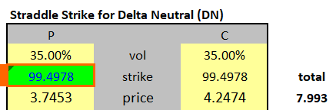

The both volatility of put and call are exactly $σ_{ATM}$ which is equal to **35%**

The strike price we can use the formula: $K=F∙e^{-1/2∙σ^{2}(T-t)}$ to calculate and is **99.4978**

And we can use BSM to calculate the price of each components which is shown above and the total cost buying the structure is **7.993** DEN per NUM payable.

**STGL**

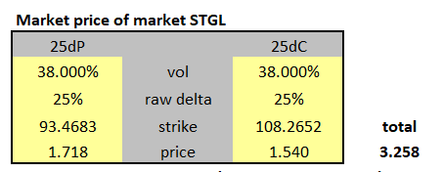

The both volatility of call and put can be calculate as $σ_{ATM}+σ_{BF}=35\%+3\%=38\%$

The Strike price of put and call can be calculate by the definition of delta

The 25DP. $-N\left(-\frac{\ln\left(\frac{100}{K}\right)+0.5*{0.38}^{2}*\left(\frac{30}{365}\right)}{0.38*\sqrt{\frac{30}{365}}}\right)=-25\%$ we get strike of put option **93.4683**

The 25DC. $N\left(\frac{\ln\left(\frac{100}{K}\right)+0.5*{0.38}^{2}*\left(\frac{30}{365}\right)}{0.38*\sqrt{\frac{30}{365}}}\right)=25\%$ we get the strike of call option is **108.2652**

The price of put option is **1.718, of call option is 1.540**

And we will cost **3.258** DEN per NUM payable to buy this structure.

**Risk Reversal**

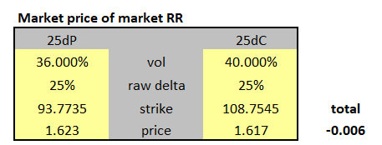

The volatility of call and put option can be calculate by using $σ_{ATM}+σ_{BF}±1/2σ_{RR}$**=40%/36%**

The 25DP. $-N\left(-\frac{\ln\left(\frac{100}{K}\right)+0.5*{0.36}^{2}*\left(\frac{30}{365}\right)}{0.36*\sqrt{\frac{30}{365}}}\right)=-25\%$ we get strike of put option **93.7735**

The 25DC. $N\left(\frac{\ln\left(\frac{100}{K}\right)+0.5*{0.4}^{2}*\left(\frac{30}{365}\right)}{0.4*\sqrt{\frac{30}{365}}}\right)=25\%$ we get the strike of call option is **108.7545**

Use BSM, we can solve the price of put option is **1.623, call option is 1.617**

We will cost **-0.006** DEN per NUM payable to buy this structure.

1. Using the smile function : for each of the market structures, calculate the volatility and price of each of its components, and the net cost of buying the structure

We use the smile function as the following:

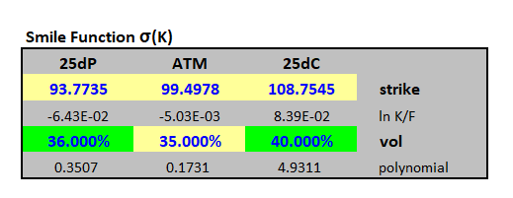

value the market structures using the smile function σ(K), three points are first required, and then a polynomial function is solved to pass through these points.

We give 25% delta put option 36% volatility, 25% delta call option 40% and call or put option at 35% volatility.

Using the smile function above we can calculate the three structure as the followings:

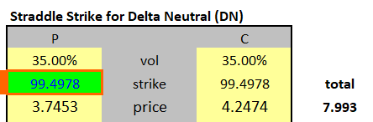 we cost 7.993 DEN per NUM for DN

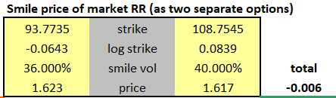 we cost -0.006 DEN per NUM for RR

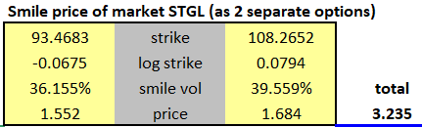 we cost 3.235 DEN per NUM for STGL

1. Solve for (calibrate) the smile function. Show the calibrated 25 delta Put option and 25 delta Call option volatilities and explain the steps you made in calibration.

What we solve is as the followings:

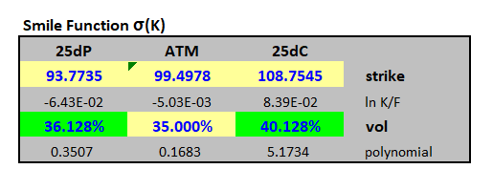

Actually is near what we guess at start.

The 25DP volatility is **36.128%**

The 25DC volatility is **40.128%**

Frist we guess a volatility for put and call option, you can just guess which are equal to the RR structure, and you will find that the error of STGL is not nil, means we should slight amend our volatility to make the error of STGL is nil. And use the linear programming to solve the vol.

1. Construct a vega-neutral butterfly as a ratio spread of delta-neutral straddles and market strangles.

We can build the vega-neutral butterfly like the following:

+VNBF = $w*DNSTDL\left(σ_{ATM}\right)-STGL(σ=σ_{ATM}+σ_{BF})$

And the Vega of DNSTDL is : 11.380+11.380 = 22.76

The Vega of STGL is : 8.805+8.690 = 17.495

Thus the riato w = 17.495/22.76 = 0.76867

So we can **long 0.76867 shares DNSTDL and short 1 share STGL to construct the VNBF.**

Or equivalently, **long 1 share DNSTDL and short 1.3010 STGL.**

1. Calculate the vega, vanna and volga of each of the delta neutral straddle, the market risk reversal, and the vega-neutral butterfly from (v). Evaluate the ‘Black-Scholes price’ for each using the atm volatility for all components

We use the atm volatility to calculate the vega, Volga, vanna and BS price as the followings:

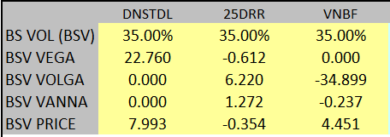

1. Calculate the weights of each of the three structures in (v) required, to build three portfolios that have:

Only Vega, no Vanna, Volga:

|  |  |  |
| --- | --- | --- |
| DNSTDL | 25DRR | VNBF |
| 1.000 | 0 | 0 |

Only Vanna, no Vega and Volga:

|  |  |  |
| --- | --- | --- |
| DNSTDL | 25DRR | VNBF |
| 0.0269 | 1.000 | 0.1782 |

Only Volga, no Vega and Vanna:

|  |  |  |
| --- | --- | --- |
| DNSTDL | 25DRR | VNBF |
| 0.0050 | 0.1863 | 1.000 |

1. For each of these three portfolios, calculate the differences between their respective weighted prices and weighted Black-Scholes prices. Calculate the implied change in price per unit of each of vega, vanna and volga.

For portfolios only have Vega:

|  |  |  |  |  |
| --- | --- | --- | --- | --- |
|  | DNSTDL | 25DRR | VNBF | Total |
| weight | 1.000 | 0 | 0 |  |
| Weight BSV PRICE | 7.9927 | 0 | 0 |  |
| Weight MKT PRICE | 7.9927 | 0 | 0 |  |
| W MKT ADJ | 0 | 0 | 0 | 0 |
| W BSV Vega | 22.760 | 0 | 0 | 22.760 |
| W BSV Volga | 0 | 0 | 0 | 0 |
| W BSV Vanna | 0 | 0 | 0 | 0 |
| ADJUST PER UNIT RISK(W MKT ADJ/W BSV Vega) | | | | nil |

For portfolios only have Vanna:

|  |  |  |  |  |
| --- | --- | --- | --- | --- |
|  | DNSTDL | 25DRR | VNBF | Total |
| weight | 0.0269 | 1.000 | 0.1782 |  |
| Weight BSV PRICE | 0.2151 | -0.3538 | 0.7933 |  |
| Weight MKT PRICE | 0.2151 | -0.0057 | 0.6690 |  |
| W MKT ADJ | 0 | 0.3480 | -0.1243 | 0.2237 |
| W BSV Vega | 0.6125 | -0.6125 | 0 | 0 |
| W BSV Volga | 0 | 6.2198 | -6.2198 | 0 |
| W BSV Vanna | 0 | 1.2720 | -0.0422 | 1.2298 |
| ADJUST PER UNIT RISK(W MKT ADJ/W BSV Vanna) | | | | 0.1819 |

For portfolios only have Volga:

|  |  |  |  |  |
| --- | --- | --- | --- | --- |
|  | DNSTDL | 25DRR | VNBF | Total |
| weight | 0.0050 | 0.1863 | 1.000 |  |
| Weight BSV PRICE | 0.0401 | -0.0659 | 4.4511 |  |
| Weight MKT PRICE | 0.0401 | -0.0011 | 3.7536 |  |
| W MKT ADJ | 0 | 0.0648 | -0.6975 | -0.6326 |
| W BSV Vega | 0.1141 | -0.1141 | 0 | 0 |
| W BSV Volga | 0 | 1.1589 | -34.8991 | -33.7402 |
| W BSV Vanna | 0 | 0.2370 | -0.2370 | 0 |
| ADJUST PER UNIT RISK(W MKT ADJ/W BSV Volga) | | | | 0.0187 |

1. For a Call option of tenor 30 days and strike 103.10, calculate the smile price using (a) the polynomial smile function, and (b) the adjustments from (vii).
2. use polynomial smile function:

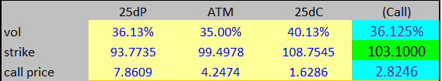

The price is **2.8246**

1. use the adjustments from(vii)

use the atm volatility 35% give the BS price is 2.70, and BS Volga is 2.849, BS Vanna is 0.391

so the adj price is :

2.7+ 2.849*0.0187 + 0.391*0.1819 = **2.8244**

And we can see the methods give the very similar answer for the price.